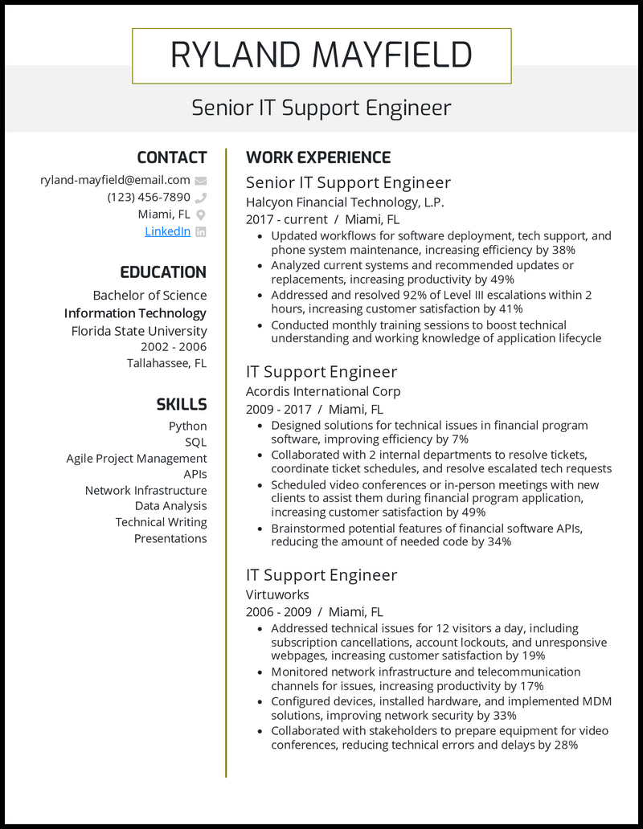
RYLAND MAYFIELD
Senior IT Support Engineer
CONTACT
ryland-mayfield@email.com
(123) 456-7890
Miami, FL
Linkedin in
EDUCATION
Bachelor of Science Information Technology Florida State University
2002-2006 Tallahassee, FL
SKILLS Python SQL
Agile Project Management
APIs
Network Infrastructure
Data Analysis
Technical Writing Presentations
WORK EXPERIENCE
Senior IT Support Engineer Halcyon Financial Technology, L.P.
2017-current / Miami, FL
·
Updated workflows for software deployment, tech support, and phone system maintenance, increasing efficiency by 38%
• Analyzed current systems and recommended updates or replacements, increasing productivity by 49%
Addressed and resolved 92% of Level III escalations within 2 hours, increasing customer satisfaction by 41%
• Conducted monthly training sessions to boost technical understanding and working knowledge of application lifecycle
IT Support Engineer
Acordis International Corp 2009-2017/ Miami, FL
• Designed solutions for technical issues in financial program software, improving efficiency by 7%
• Collaborated with 2 internal departments to resolve tickets, coordinate ticket schedules, and resolve escalated tech requests • Scheduled video conferences or in-person meetings with new clients to assist them during financial program application, increasing customer satisfaction by 49%
• Brainstormed potential features of financial software APIs, reducing the amount of needed code by 34%
IT Support Engineer
Virtuworks
2006-2009/ Miami, FL
• Addressed technical issues for 12 visitors a day, including subscription cancellations, account lockouts, and unresponsive webpages, increasing customer satisfaction by 19%
• Monitored network infrastructure and telecommunication channels for issues, increasing productivity by 17%
• Configured devices, installed hardware, and implemented MDM solutions, improving network security by 33%
• Collaborated with stakeholders to prepare equipment for video conferences, reducing technical errors and delays by 28%

